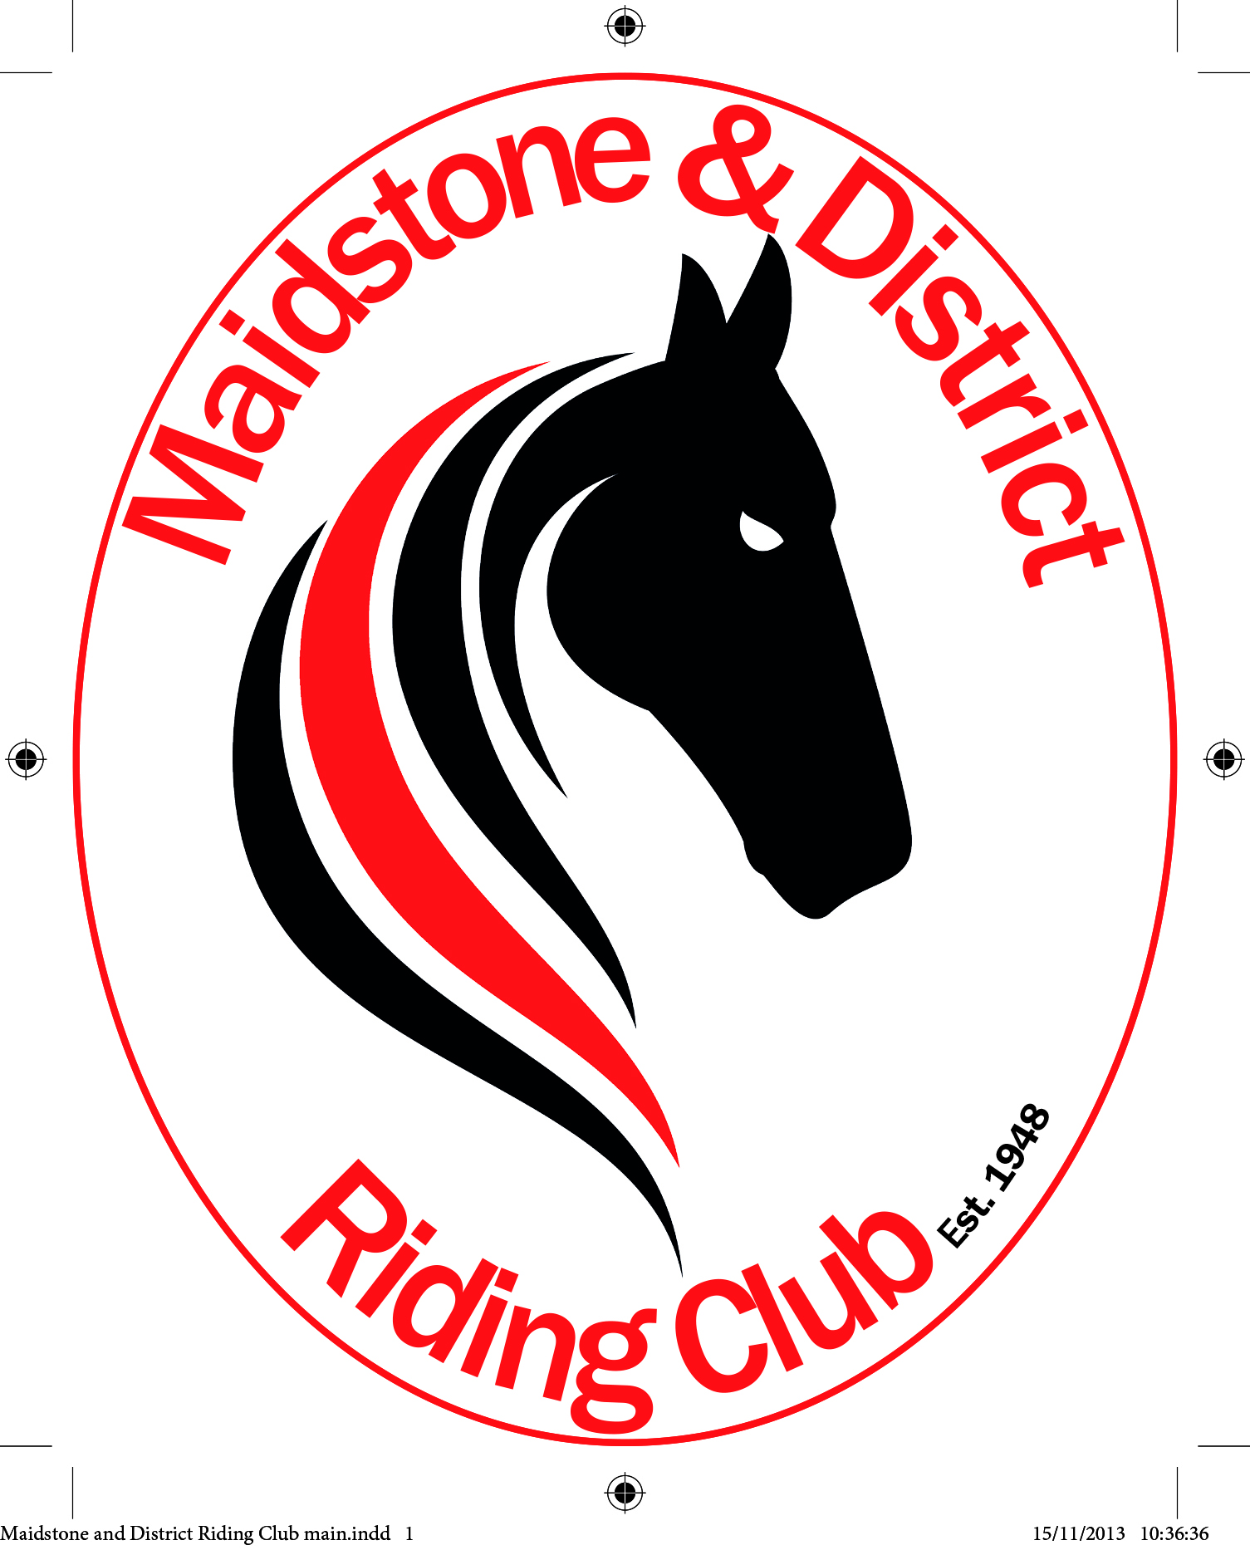

We are very excited to announce that MDRC are organising a coach trip to Olympia this year! It will be on Saturday 22nd of December for the evening performance and the price of £74.75 includes ticket and coach travel.

The coach will be leaving at midday from the car park at the top of Bluebell Hill, by Hospital Lane Dental Centre, and we will be picked up at the end of the performance outside Olympia and dropped back to Bluebell Hill.

Please let Sarah Hall know asap if you are interested in booking as she needs to confirm numbers. Her email is sarahhall007@btinternet.com

